**Appendix “F”**

**User’s Guide**

**SYSTEM OVERVIEW for ORDINARY USER**

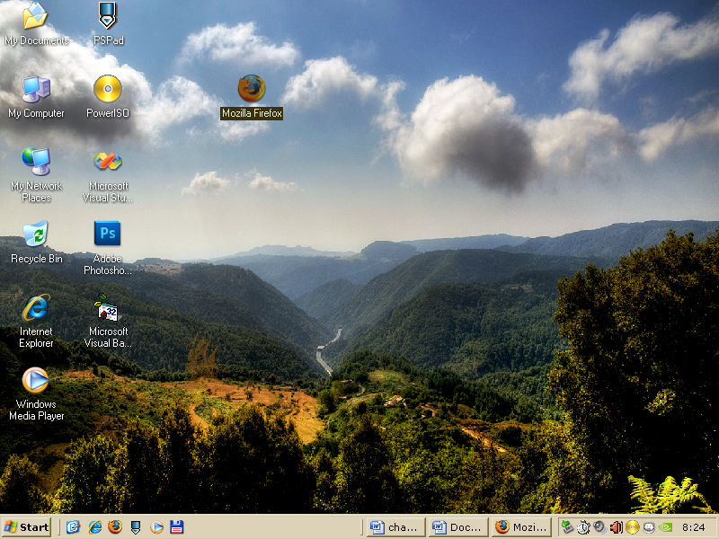**Steps on how to operate the system**

1. The first step is clicking the web browser whether it is Mozilla Firefox or internet explorer or other browser.

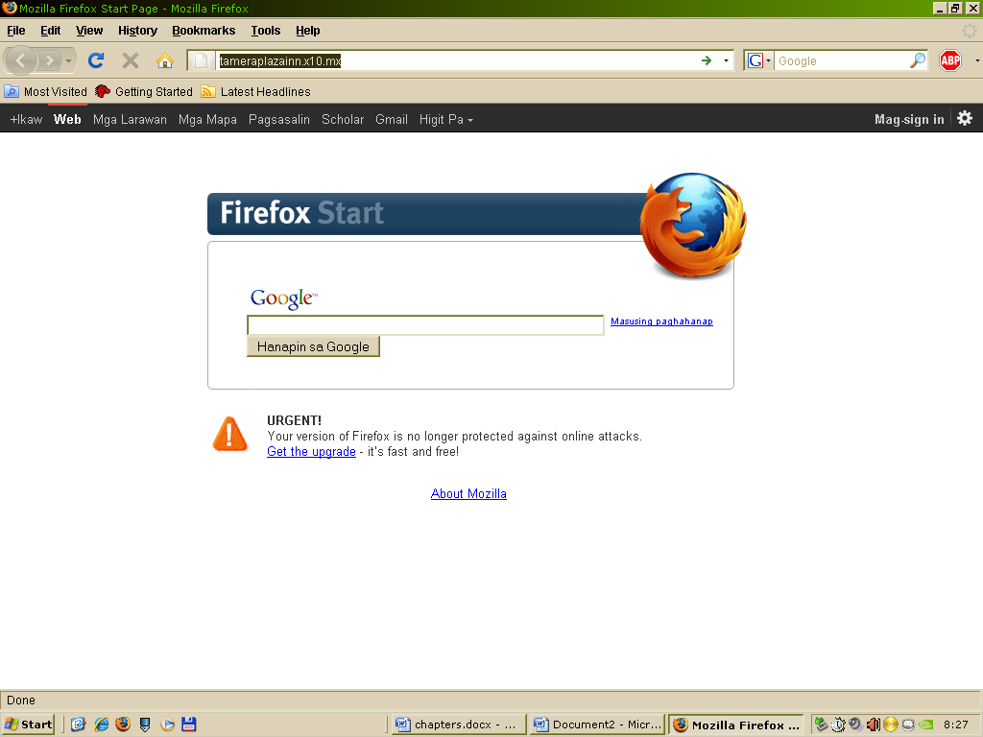

1. After clicking the web browser type the name of the website at the url. Example: http://www.tameraplazainn.x10.mx

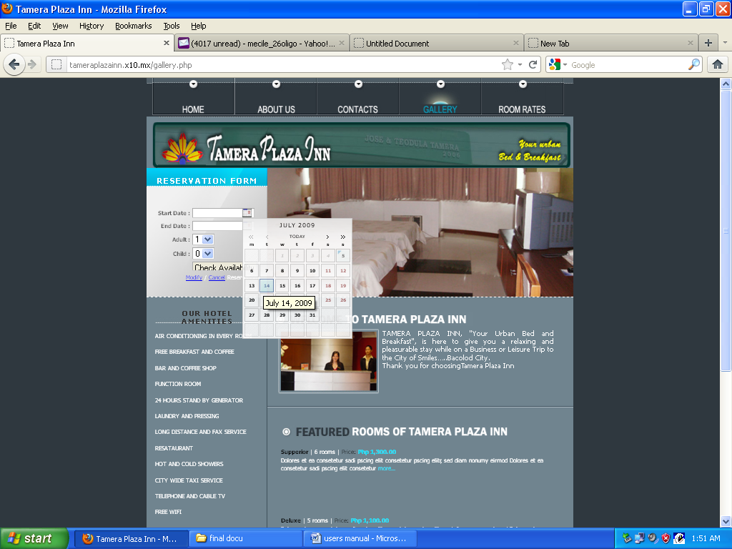**Steps on how to make online reservations**

1. After entering the site choose first reservation dates for check in and check out reservation form.

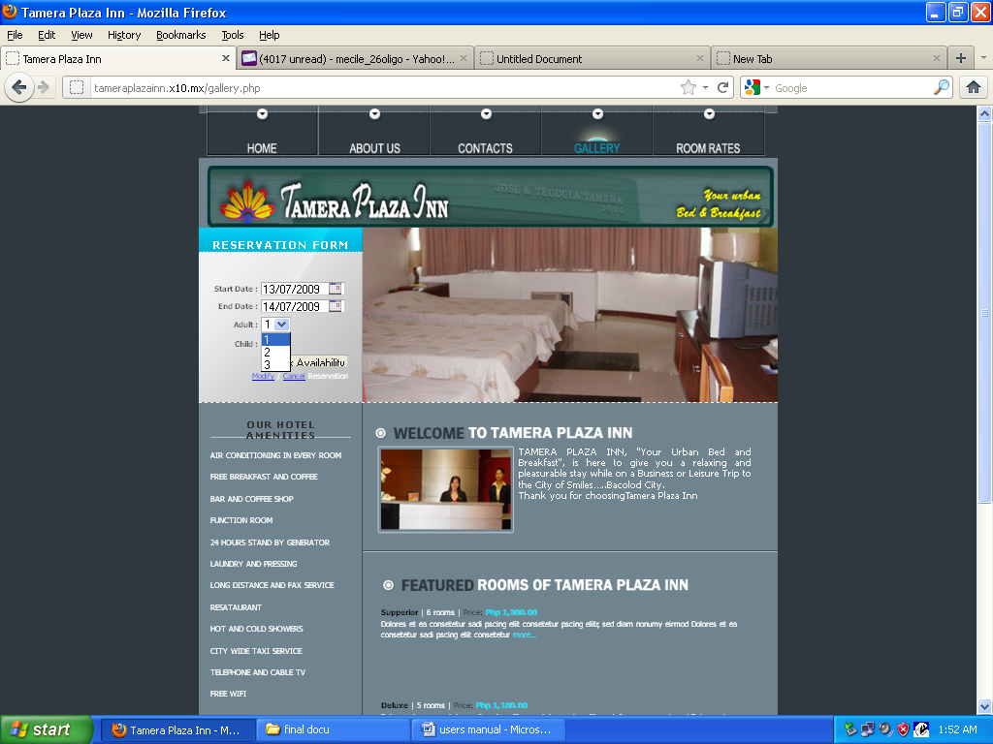

1. Choose how many adults and child to input.

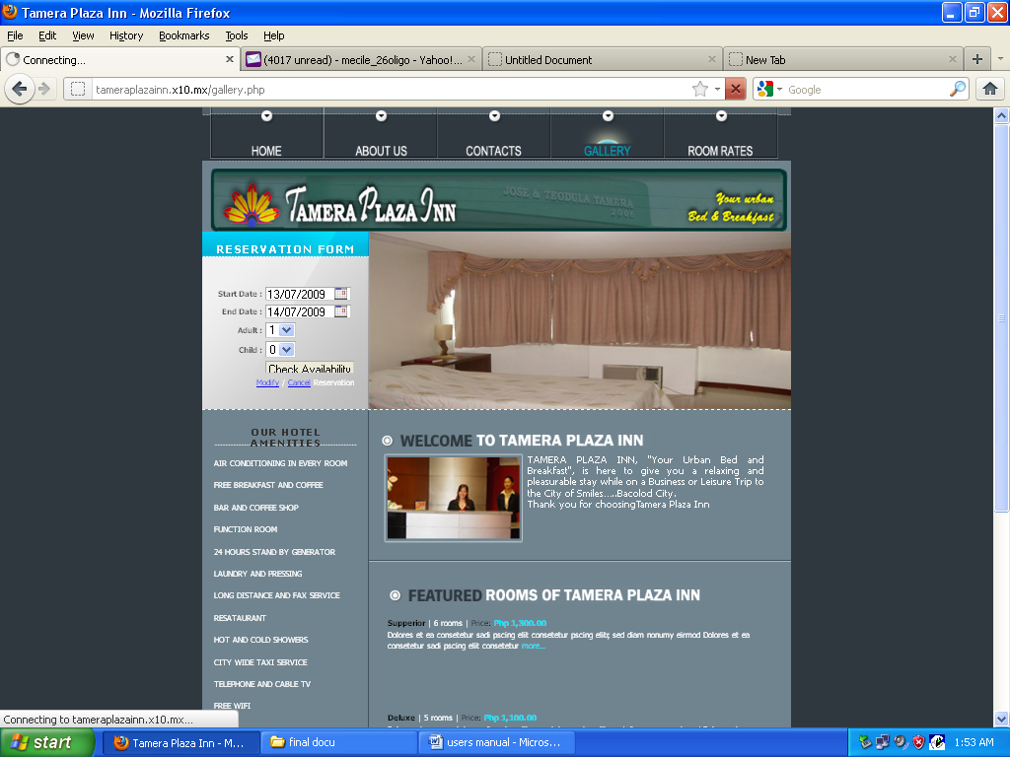

1. Click the button check availability to check if there are available dates.

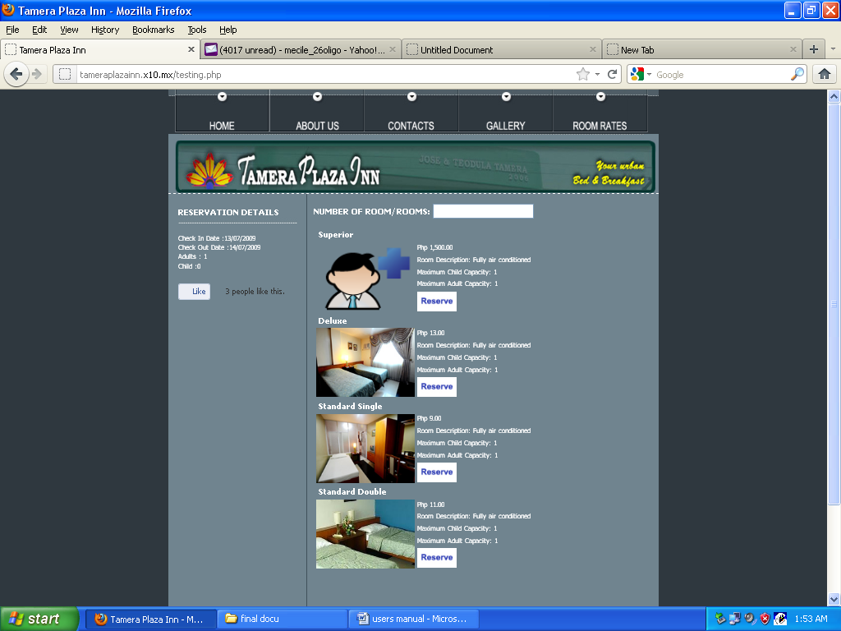**Steps on how to select room**

1. After checking availability you can now select what types of room to acquire

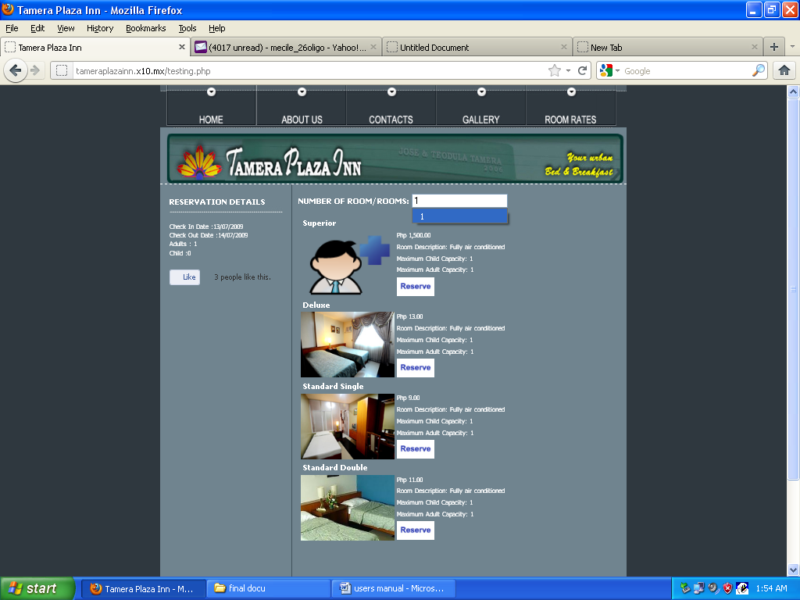

1. After checking room type, indicate at the box on how many rooms would the customer wants to acquire.

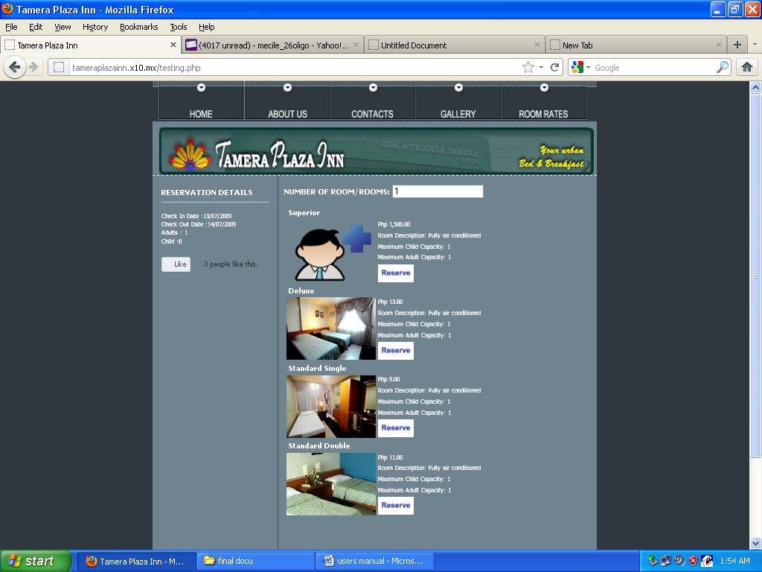

1. Click reserve button to continue reservation.

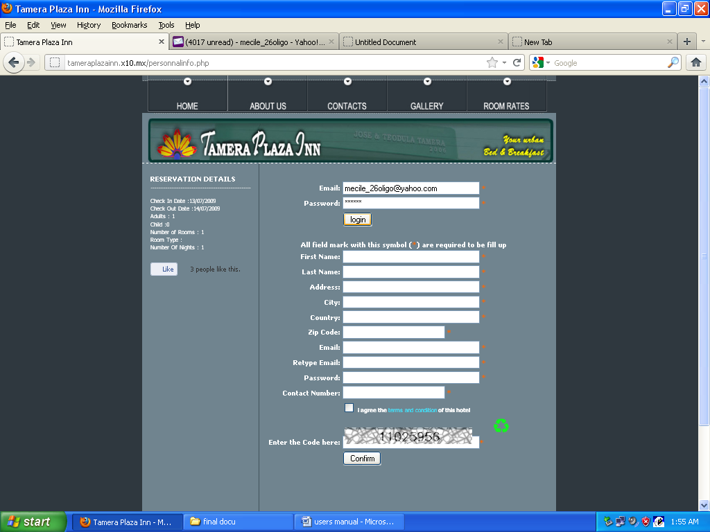**Steps on how to log-in/sign up information**

1. Log-in if the customer have already an account. Input username and password.

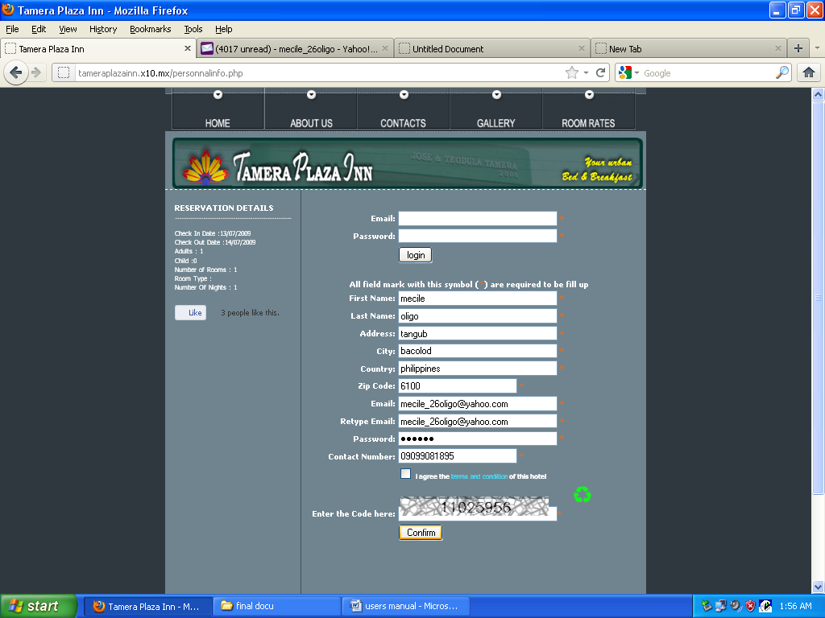

1. If not fill up the form to have an account. Input name, address, contact number and email address.

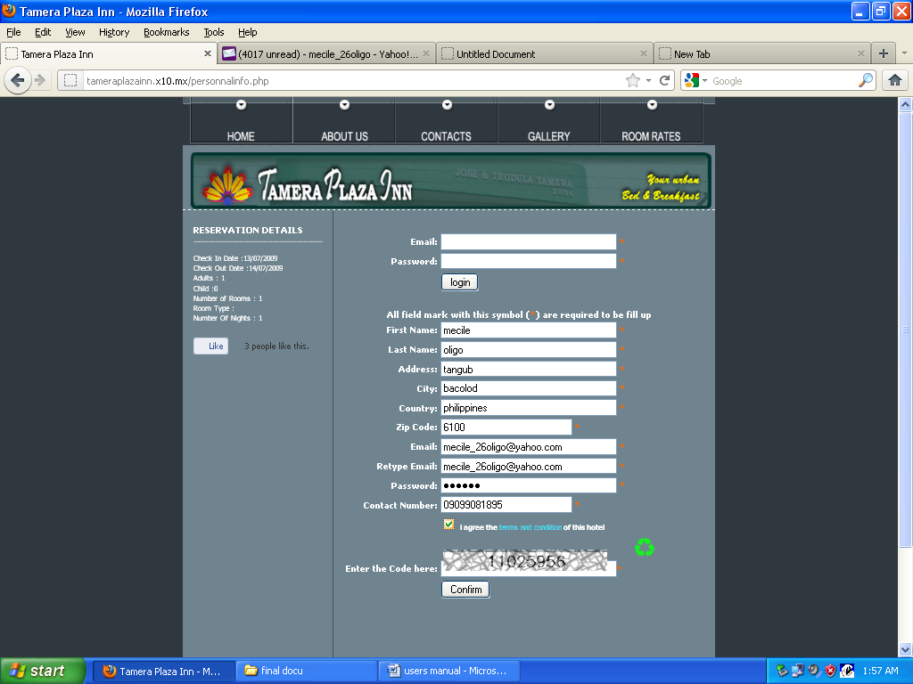

1. Check the check box if already agreed at the terms and condition of the hotel.



1. Enter verification code for security.

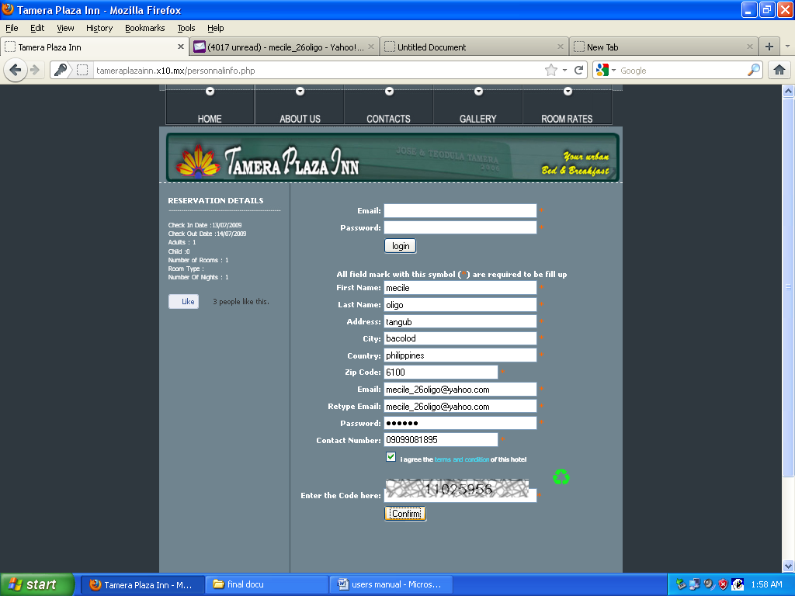

1. Click the continue button to proceed at payment form.

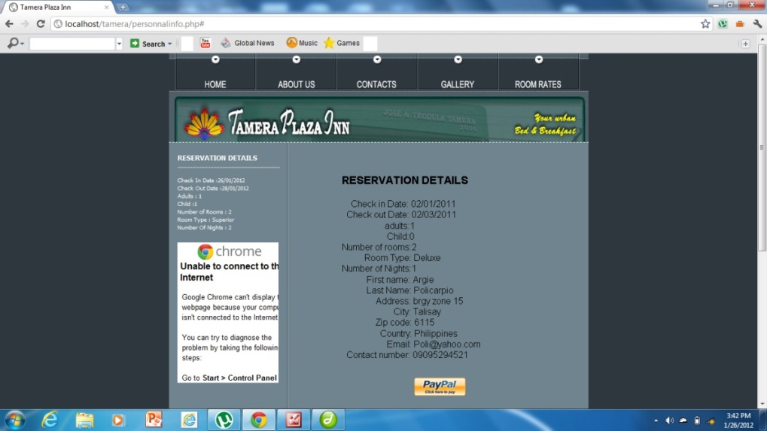

1. Click Pay Now Button for using Reservation.

**Steps on how to pay using pay pal**

First you have to register your details (including Credit Card details) with PayPal.

**How do I register with PayPal?**

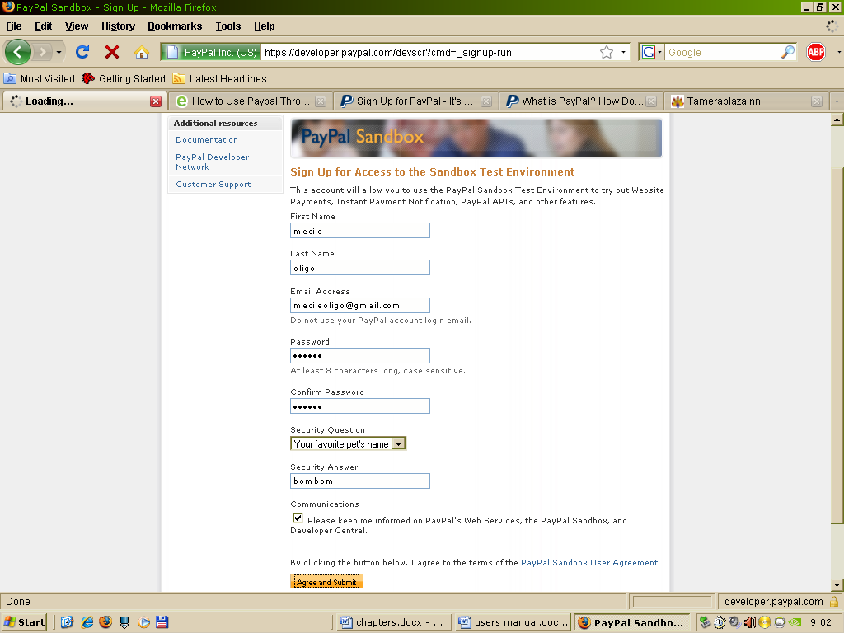

1. Go to the PayPal home page you will be taken to the initial sign up page.

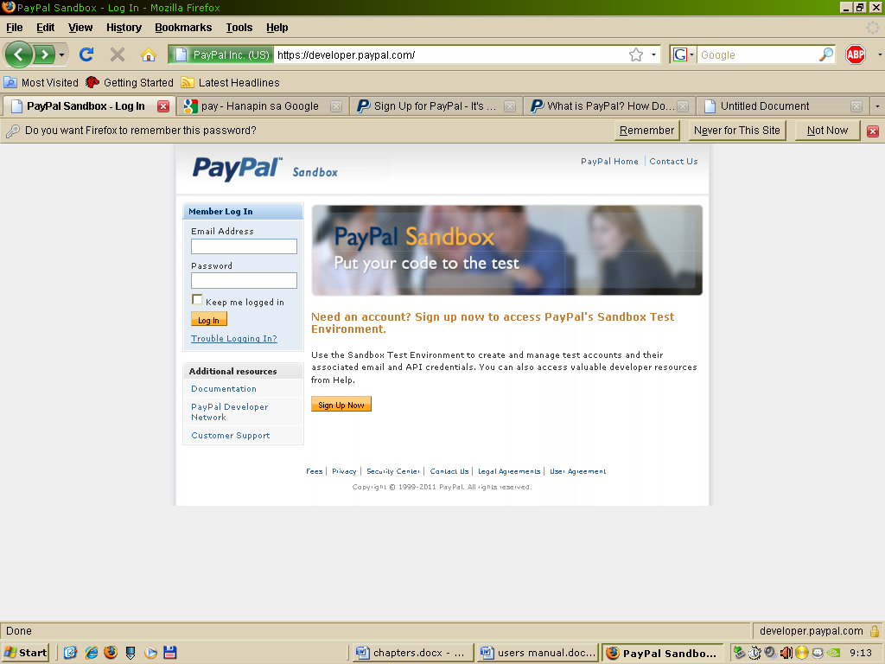

1. Now, you will only need a personal account, so make sure the "Personal Account" option is selected then click on the Continue button.

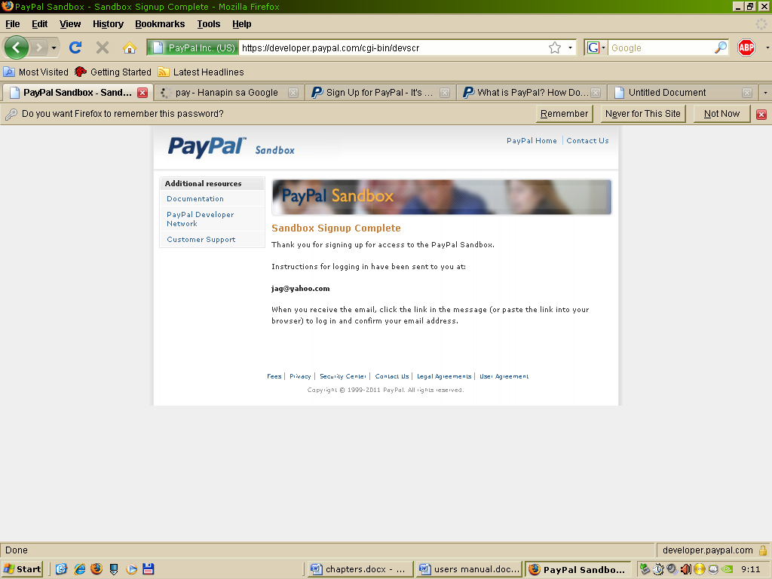

1. You are now on the page with the form which you complete and submit.

**How do I send an order and payment to you for the book?**

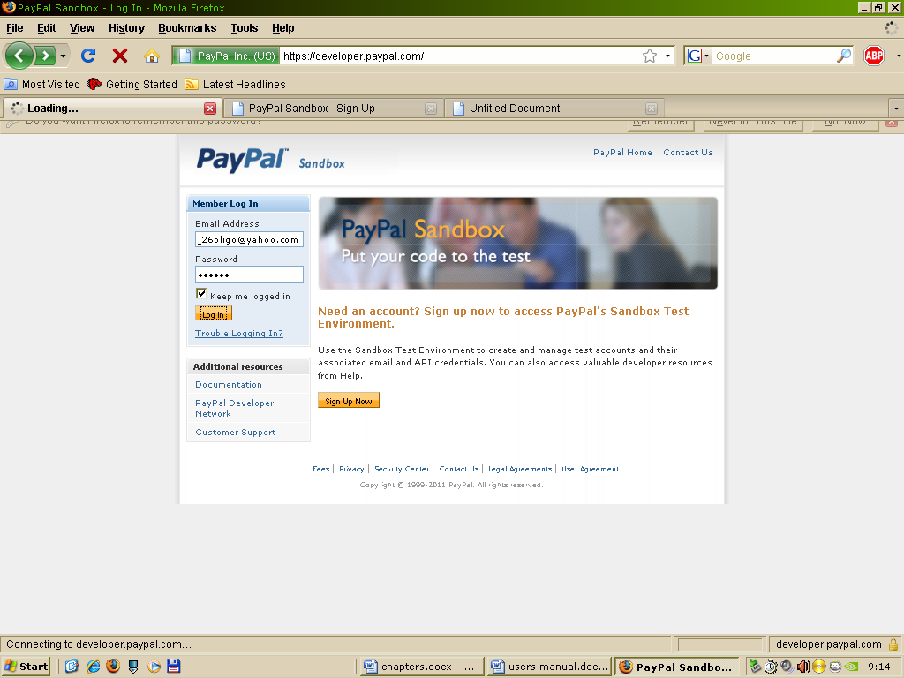

1. On the PayPal home page, just fill-in your email address & password in the member’s log-in section, and click the Log-in Button:

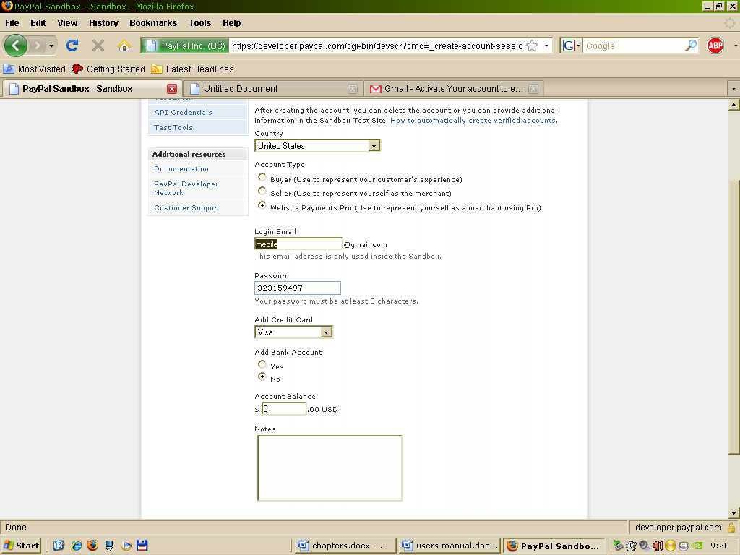

1. On this secure page, fill in the relevant details: my email address, the amount of money, selects the correct currency. Double-check that the email address is correct.

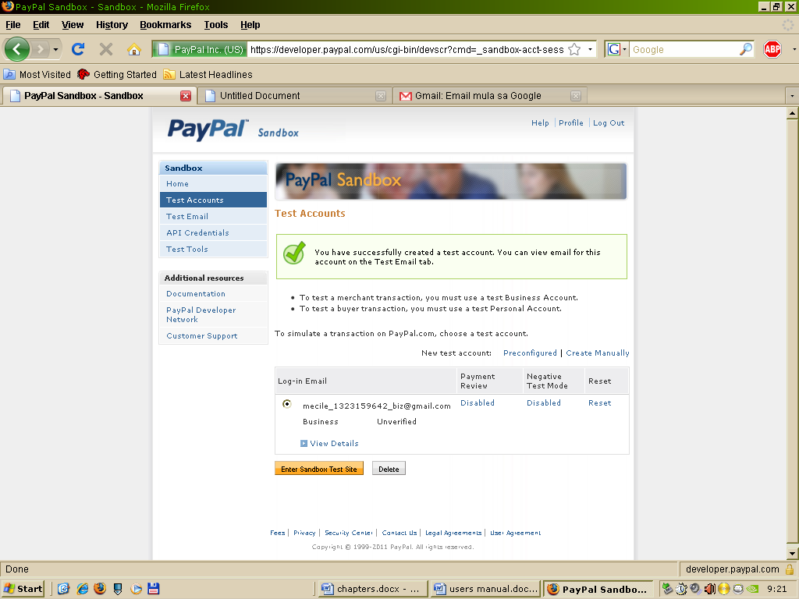

1. Click the Continue button and just follow PayPal instructions.

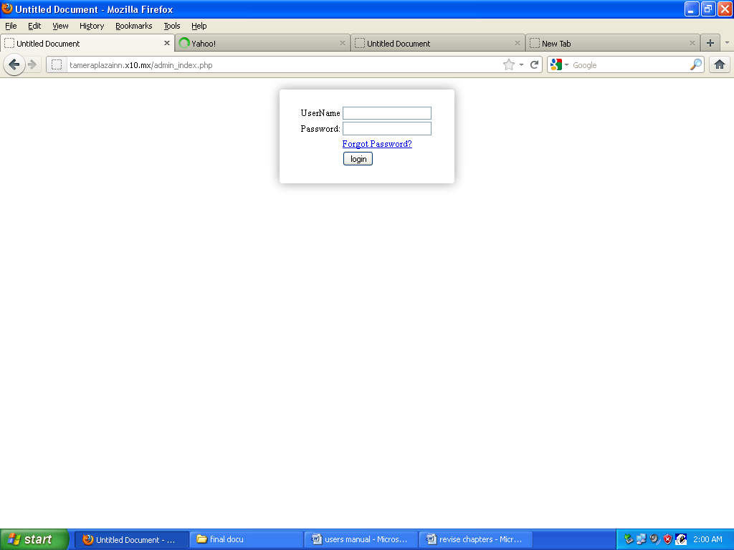**SYSTEM OVEREVIEW for ADMINISTRATOR**

1. The administrator will log-in to the admin page. Input username and password then click login.

**How to monitor reservation**

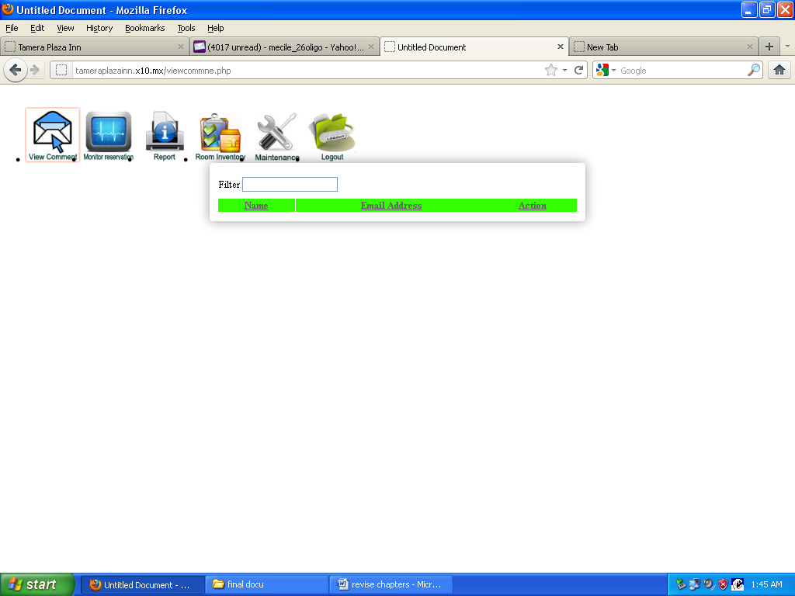

1. Click monitor reservation to view the contents of information.

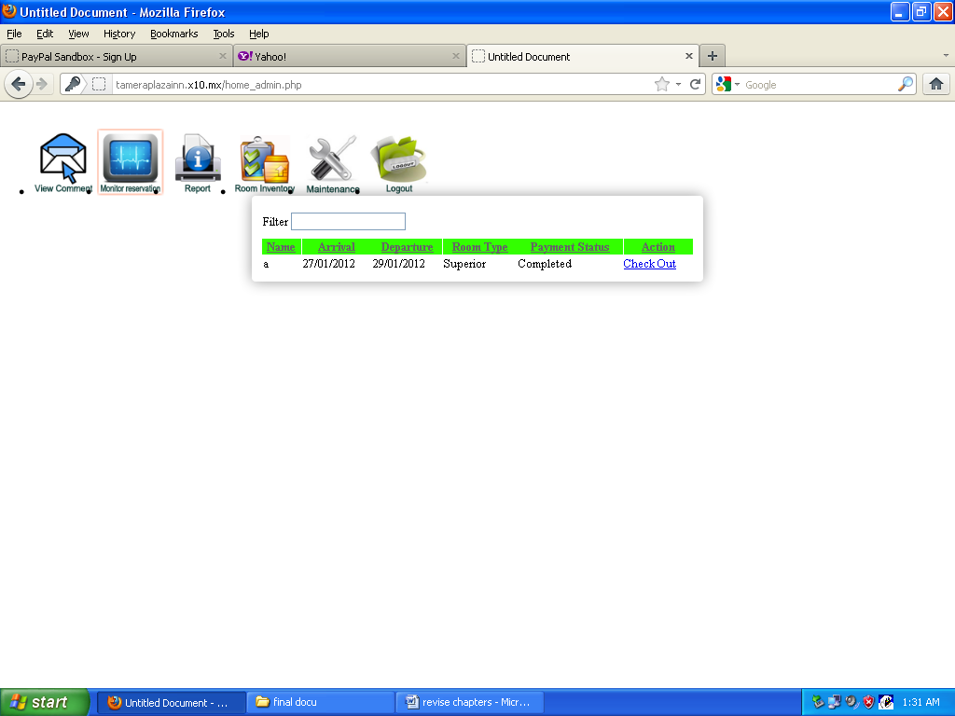

1. The admin can view booker information the arrival and departure dates, room type and number of nights stay.



1. Admin can take an action to check out the booker.

**How to view Booker Comments**



1. Click booker comments to read the comments of the booker.



1. Take an action to read the message.

**How to generate reports**



1. Click generates reports

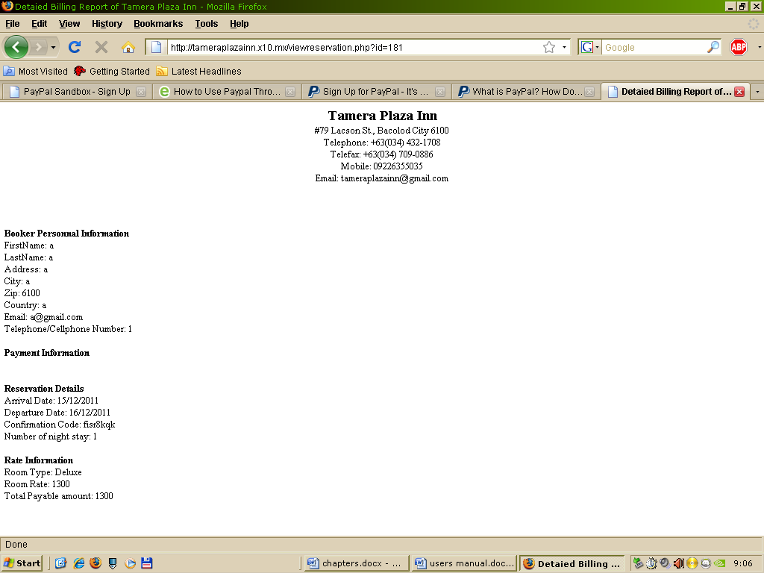

1. Admin can take an action to preview the information.

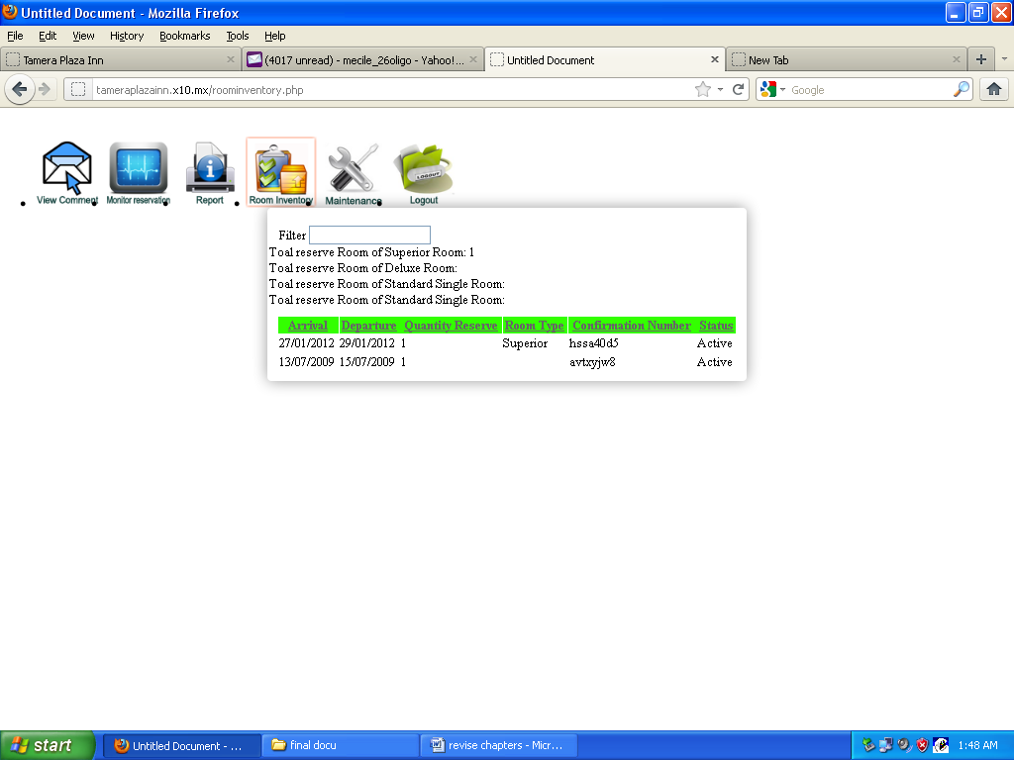**How to add rooms**

1. Click add room for another room description.



1. Input room type, room rate, quantity, description and select room image.



1. Click save button.

**How to edit rooms**



1. Select what room to edit



1. Edit room information.



1. Click save button

**How to delete rooms**



1. Select what room to delete and click delete button.